- Ad Standards has made it clear that “it is not intended that the Code govern or restrict the free expression of public opinion or ideas through ‘political advertising’ or ‘election advertising’, which are excluded from the application of this Code.”
- The Code defines “political advertising” as “‘advertising’ appearing at any time regarding a political figure, a political party, a government or political policy or issue publicly recognized to exist in Canada or elsewhere, or an electoral candidate.”
- Elections Ontario defines political advertising in a similar fashion to include advertising that “takes a position on an issue that can reasonably be regarded as closely associated with a registered party or its leader or a registered candidate”.
The Premier’s tweet, which is reproduced below, in our view, falls within Ad Standard’s definition of political advertising.
Figure 1 – Tweet of Premier Kathleen Wynne (December 23, 2017, 6:05 am)
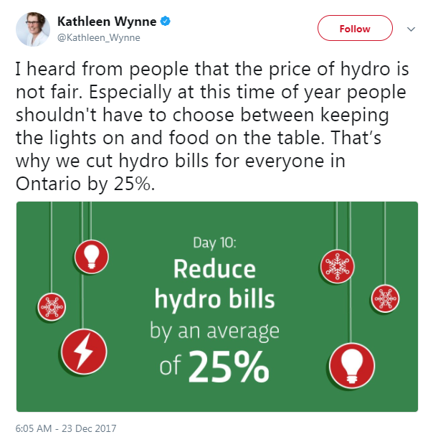
- The policy being expressed by the Premier in this communication is the reduction of electricity bills by 25%. This is a policy being promoted to the electorate by the Premier.
- It would be inappropriate for Ad Standards or a Standards Council to treat communications from the Premier expressing a policy choice as reviewable advertising, which is presumably why the Code includes an express exemption for political advertising.
- Political expression is considered a value at the core of the freedom of expression guarantee set out at section 2(b) of the Canadian Charter of Rights and Freedoms. The Supreme Court of Canada has repeatedly affirmed the importance of protecting political expression from interference, which is why there can be no lawful regulation over the content of political advertising. This ensures that “political views are allowed to be disseminated without inference of other interest biases, and without discrimination based on content, unless that content is so extreme as to offend the values underlying Canadian democracy.”
- The Premier is not the only political figure who is making claims on these policies, further evidencing the political nature of the statement. Set out below are tweets from Progressive Conservative Leader Patrick Brown and New Democratic Party Leader Andrea Horwath who have both advocated policy changes to reduce electricity bills by 25% or more – neither of whom included any disclaimers or explanatory language in their communications.
Figure 2 – Tweet of Opposition Leader Patrick Brown (November 25, 2017)
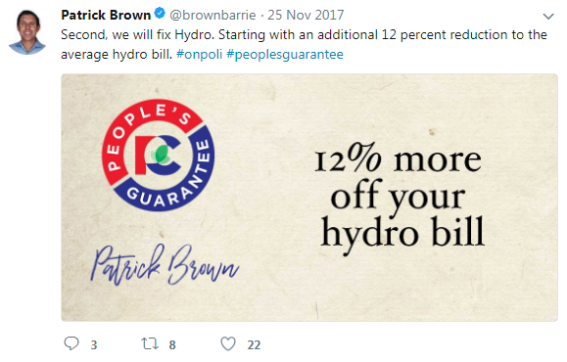
Figure 3 – Tweet of Opposition Leader Andrea Horwath (May 9, 2017)
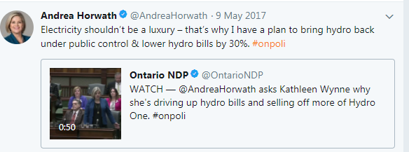

See “Exclusions”, online: http://www.adstandards.com/en/Standards/canCodeOfAdStandards.aspx#codeProvisions.
Emphasis added.
See “Election Finances Bulletin – Information for Third Party Advertisers”, online: https://www.elections.on.ca/content/dam/NGW/sitecontent/2017/politicalentities/Election%20Finances%20Bulletin%20-%20Information%20for%20Third%20Party%20Advertisers.pdf.
For additional context, the advertising provisions of the Competition Act do not apply to political advertisements since the advertising must relate to the supply or use of a product or service or for the purpose of promoting a business interest. See Competition Act, R.S.C. 1985, c. C-34, s. 74.01(1).
See R. v. Keegstra, [1990] S.C.J. No. 131 at para. 89: “The connection between freedom of expression and the political process is perhaps the linchpin of the s. 2(b) guarantee, and the nature of this connection is largely derived from the Canadian commitment to democracy. Freedom of expression is a crucial aspect of the democratic commitment, not merely because it permits the best policies to be chosen from among a wide array of proffered options, but additionally because it helps to ensure that participation in the political process is open to all persons.” See also Edmonton Journal v. Alberta (Attorney General), [1989] 2 S.C.R. 1326 at 1336: “It is difficult to imagine a guaranteed right more important to a democratic society than freedom of expression. Indeed a democracy cannot exist without that freedom to express new ideas and to put forward opinions about the functioning of public institutions. The concept of free and uninhibited speech permeates all truly democratic societies and institutions. The vital importance of the concept cannot be over-emphasized.” See further R. v. Sharpe, [2001] 1 S.C.R. 45 at para. 23: “While some types of expression, like political expression, lie closer to the core of the guarantee than others, all are vital to a free and democratic society”.
Brenda Pritchard and Susan Vogt, Advertising and Marketing Law in Canada, 5th ed. (Lexis: Toronto, 2015), p. 567. See also Canadian Radio-Television and Telecommunications Commission, Broadcasting Information Bulletin CRTC 2014-214, “Guidelines for all licensees of broadcasting undertakings serving the province of Ontario – Provincial election”, Canadian Radio-television and Telecommunications Commission (May 6, 2014), online: http://www.crtc.gc.ca/eng/archive/2014/2014-214.htm, which provides: It is the broadcaster’s duty to ensure that the public has adequate knowledge of the issues surrounding an election and the position of the parties and candidates. The broadcaster does not enjoy the position of a benevolent censor who is able to give the public only what it “should” know. Nor is it the broadcaster’s role to decide in advance which candidates are “worthy” of broadcast time.

