Appendix 3 Mechanics of Ontario’s Fair Hydro Plan

This document provides an overview of how the Fair Hydro Plan is expected to work. It is based on OPG Management’s understanding of the process that will be finalized in legislation, regulation and contracts. Some portions of the process have yet to be defined.

Overview of the FHP

On March 2nd, the Ontario government announced its proposed Fair Hydro Plan (FHP). The plan proposes to lower the average residential electricity bill by 25 percent. This will be accomplished by:

- The Ontario Rebate for Electricity Consumers (OREC) rebate of the provincial portion of HST (~5.7% of the original bill after-tax reduction)
- Shifting social programs from electricity ratepayers to taxpayers (approximately 1.6%), and
- Reallocating the payment of a portion of the Global Adjustment to realign the charges paid by ratepayers for new generation contracts and conservation programs over an extended period to match the re-evaluated expected life of the assets and the benefits of these initiatives (17.7%).

The government has further committed to capping the increase on the average residential bill at the rate of inflation for three years following the initial year.

The average residential electricity bill will be determined by a proxy customer whose distributor is Toronto Hydro and who consumes 750 kilowatt-hours of electricity per month.

In order to reallocate the Global Adjustment payments, the Financing Entity will use debt to purchase Investment Assets from the IESO and amortize them over a longer period. This will lead to a near-term reduction electricity bills followed by an increase in electricity bills over the long-term as interest and principal is repaid.

Structure of the FHP

The Ontario government’s proposed legislation will provide OPG, as the Financial Services Manager, with the opportunity to form and operate the Financing Entity and defines the roles and obligations of OPG, the Financing Entity, the Ontario Energy Board (OEB) and the Independent Electricity System Operator (IESO).

The OEB currently sets the Regulated Price Plan (RPP) prices in May and November. RPP sets the price that the LDC’s charge for commodity cost line item for most residential bills in their service area. The OEB sets RPP prices to target recovery of commodity costs allocated to RPP customers.
The OEB will continue in its role of setting RPP prices with the following new conditions over the following periods:

- 25% Reduction (May 2017)
  - The average bill will be reduced by 25% inclusive of OREC and social programs noted above
  - The OEB reduced RPP bills to reflect 50% of the reallocation savings May 1 and will reduce RPP prices further in summer 2017 once legislation is passed.
- Inflation Period (May 2018 – April 2021)
  - RPP price will be set such that total bill increases will be capped at the rate of inflation

- Recovery Period (2021 to 2047)
  - RPP prices will be determined by the OEB ensuring the full recovery of the principal, interest and all fees included in the funding obligations
    - Straight-line Increase Period (May 2021, for up to 6 years)
      - OPG will recommend to the OEB a straight-line rate (e.g., 8% per year) to increase bills over the period to:
        - Ensure that borrowing will not exceed the Financing Entity’s capacity, and
        - Increase the revenue recovered from eligible customers to exceed actual system costs with the excess available to pay interest and repay debt by 2047.
    - Amortization Period (End of Straight-line Increase Period – April 2047)
      - Ratepayers will repay debt built up over the previous periods as well as interest

The impact on the average residential bill is illustrated below.

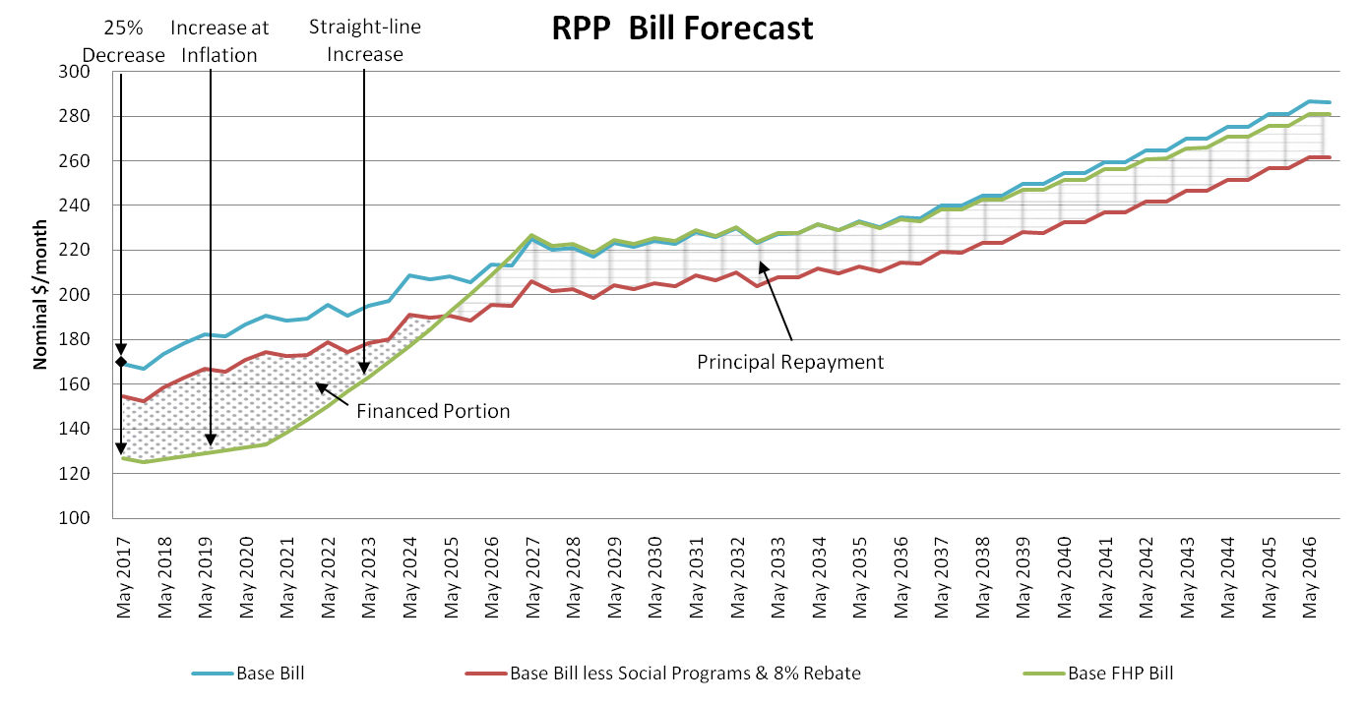

The IESO will continue to operate the wholesale electricity market, pay generators contracted amounts and collect revenue from RPP customers via LDCs. The OEB will issue an accounting order that will authorize the IESO to create a variance account to manage the difference between actual costs and the RPP prices for eligible customers. These variances will be offered for sale monthly as an “Investment Asset”. OPG will establish a Financing Entity to purchase these assets. The Financing Entity will have a right but not an obligation to acquire the Investment Assets. In exchange for buying the Investment Asset, the Financing Entity will receive the right to recover its principal, interest, fees, and all financing charges from ratepayers during the Amortization Period (2026-2047 in OPG’s base forecast).

Impact on Electricity Bills

The FHP legislation essentially fixes electricity bills via the 1 year 25% reduction and 3 years where bills are capped at inflation. In reality, actual system costs will vary and must be recovered and paid out to generators, transmitters, distributors, etc.

OPG has undertaken extensive forecasting of how these system costs will evolve to determine how much debt the Financing Entity will need to take on to achieve the requirements set out in the legislation and regulations. Specifically, OPG has modelled the commodity cost line of electricity bills which includes costs related to electricity generation and conservation. OPG has included forecasts of OPG generation rates based on the current rate case including the proposed smoothing mechanism. In addition, given OPG does not have access to other generator’s contracts, OPG has also included its up-to-date understanding of costs associated with other generation contracts. OPG is relying on the IESO’s forecast of conservation costs going forward.

For the other components of the bill (Distribution, Transmission, and Regulated Charges), OPG is relying on forecasts produced by the IESO. The IESO forecasts are for 20 years and OPG extrapolated the forecasts out to 2047. Finally, OPG is relying on a Ministry of Energy forecast of the savings from moving the electricity social programs from the rate base to the tax base.

The following illustrates the components of an average residential bill along with the savings introduced by the FHP:

Status Quo Monthly Bill ($/Month) |  |  |  | May - Oct 2017
Commodity (excludes line losses) |  |  | 89.35
Distribution (includes line losses) |  |  | 41.61
Transmission |  |  | 13.10
Regulated Charges (Wholesale Uplift) |  |  | 5.72
Total Base Bill before Taxes |  |  | 149.78
Harmonized Sales Tax (HST) Rate |  | 13% | 19.47
Total Base Bill After Taxes |  |  | 169.25
 |  |  |  |  | After-Tax Impact Compared to Status Quo
FHP Monthly Bill ($/Month)
Total Base Bill before Taxes |  |  | 149.78
Impact of tax-basing social programs |  |  | (2.41) |  | -1.6%
Financing Entity Financing Impact |  |  | (26.48) |  | -17.7%
FHP Bill before Taxes |  |  | 120.90
Harmonized Sales Tax (HST) Rate |  | 13% | 15.72
Ontario Rebate for Electricity Consumers |  | 8% | (9.67) |  | -5.7%
Total FHP Bill |  |  | 126.94 |  | -25.0%

The commodity cost line of electricity bills is made up of two major components: wholesale market costs and the Global Adjustment. Wholesale market costs are the money paid out to generators such as OPG for what they have earned participating in the wholesale electricity market. While most generation must be bid into the wholesale market, virtually all generation in Ontario is either contracted or regulated and thus receives additional compensation for their output beyond the wholesale market price. The Global Adjustment makes up the differences between what generators earn via the wholesale electricity market and their contracted or regulated rate. The cost of conservation programs is also passed on to ratepayers via the Global Adjustment.

Savings from the financing undertaken by the Financing Entity will appear on residential bills via a reduction in the commodity cost line item.

All electricity consumers who are eligible for the Ontario Rebate for Electricity Consumers (rebate of provincial portion of HST) will be eligible to receive the benefits of the FHP. These consumers are mostly residential customers, but also include farms and some small commercial customers. The Ministry of Energy estimates the 50% of Ontario electricity consumption will be eligible for the program.

Implications of the FHP Structure

If actual electricity system costs are higher than expected, more debt will have to be taken on to maintain bills at the fixed level set out by legislation. Bills will also need to increase faster during the Straight-line Increase Period to maintain borrowing within the Financing Entity’s capacity.

Even though the savings from the FHP will be achieved via the Global Adjustment, cost increases beyond forecast increases in other components of the bill will require additional borrowing because the FHP targets fixed total bills. For example, if Toronto Hydro or Hydro One have rates approved that are higher than forecast by the IESO, more debt will be necessary to maintain bills at the fixed level.

Additionally, OPG forecasts generation costs based on a ‘weather normal’ situation. In reality, weather is different every year. Extreme weather (very hot/cold) is expected to increase system costs, requiring additional borrowing by the Financing Entity.

OPG has analyzed sensitivities on a variety of key electricity system cost drivers including electricity demand, natural gas prices, carbon prices, nuclear refurbishment cost, exchange rates, and delivery charges. If these variables drive electricity system costs higher than expected, additional borrowing will be necessary. However, it is expected that the Financing Entity will be able to manage borrowing within its capacity under the sensitivities analyzed. Appendix 8 outlines the financial implications of these sensitivities.

Implementing the FHP

The Province’s proposed legislation will define regulated assets to defer costs, create the Fair Allocation Plan to establish the basis for cost and benefit allocation to future customers, and establish the Financing Plan to acquire the regulated assets and allow their amortization to future electricity bills. The Fair Allocation Plan will be established initially by the Province to set out a fair allocation for the costs and benefits of the Province’s clean energy initiatives (e.g. gas, wind and solar generation under 20-year contracts that can last for 30-years, conservation programs). The Province has engaged Navigant Consulting to assist in this regard. Based on preliminary estimates, costs from clean energy initiatives to be amortized to future appear to be sufficient to support the planned borrowing to the Financing Entity.

OPG will be appointed as the Financial Services Manager to develop and implement the Financing Plan consistent with the Fair Allocation Plan. As the Financial Services Manager, OPG will have the responsibility to update the Fair Allocation Plan after its initial formation by the Province using a methodology established in the proposed legislation or regulations. If subjected to challenge or amended such that the Fair Allocation Plan cannot support the planned level of borrowing, future borrowing would be curtailed.

