Fair Allocation Curve
Purpose
The Ministry of Energy has provided OPG with a verbal update on their work regarding the fair allocation curve.
Key Updates
- The Ministry believes that it only has legal justification to use the Fair Hydro Plan to reduce electricity bills for 4 years (at -25% plus inflation). There will be a small amount of potential reduction remaining after 4 years.
- If no other measures are taken, electricity ratepayers would face a significant increase in bills at this time (as high as 20-25%).
- The Ministry is working to remove costs from the electricity system during this period but will likely need to use the tax base to smooth the increase in electricity bills.
Fair Allocation Curve Methodology
- The Ministry hired Navigant Consulting to assess the useful life and benefits of investments in Ontario’s electricity system since 2005 including:
  - Gas
  - Wind
  - Solar
  - Conservation
  - Coal contingency support payments (CSPs)
Navigant Findings
Key asset life assumptions are set out in the following table:
Investment | Contract Life | Initial Useful Life | Additional Life
Gas | 20 years | 32 years | 8 years – Major maintenance investment
Wind | 20 years | 25 years | 25 years – Requires rebuild at original cost
Solar | 20 years | 25 years | 25 years – Requires rebuild but at much lower cost
Conservation | Expensed in year | 10 year persistence | N/A
Coal CSPs | 2009-2014 | 40 years (life of replacement gas plants) | N/A

- Because the contracted lives are shorter than the useful lives, Navigant then reallocated the cost of the clean investments over the full useful life. As a result, ratepayers were theoretically overpaying for the clean energy costs in the past and will continue to do so for a number of years.
- This overpayment is the legal justification for the FHP. The FHP aligns the costs of the clean investments with their true useful life.
- The amounts that ratepayers overpaid in the past can be thought of as a ‘piggy bank’ of overpayment that can be brought forward to the present to reduce bills further than can be justified by the reallocated costs alone. Navigant calculated the ‘piggy bank’ at $8.2 billion before interest.
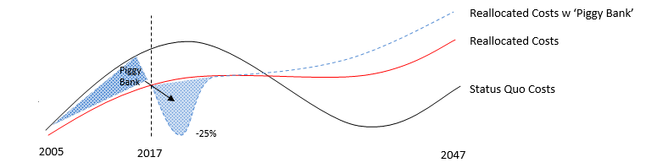
- In total Navigant calculated that a maximum of $23 billion in debt can be taken on under the FHP. This debt would be used to fund reductions in bills as well as interest on debt used to fund previous reductions.
- For calculating the interest cost of carrying the capital over a longer period as well as interest on the past overpayment ‘piggy bank,’ Navigant used a 4.5% interest rate which is based on the social discount rate.
Implications for the FHP/Trust
- The Trust can only purchase regulatory assets if financing obligations related to the purchase align with the Fair Allocation curve.
- The Fair Allocation curve is not expected to be sufficient to facilitate the full reductions that were originally envisaged by government in the later years of the FHP.
- As a result, when the FAA has been used up, the government is expected to recognize this and instruct the OEB to set rates to recover actual electricity system costs. As such the IESO will not have a collections deficiency and will not need to create a regulatory asset to be purchased by the Trust.
- If the government still wishes to reduce electricity rates, it can do so using tax funding outside of the FHP such as by increasing the 8% HST rebate.
- It is uncertain how ratings agencies will react to forecasts that bills will increase dramatically when the FAA has been used up. There could be concern related to political action to manage customer dissatisfaction. Clarity that the government will use the tax base outside of the FHP to smooth bill increases may help mitigate any potential concerns.
Next Steps
- The Ministry and Navigant have further work to do to refine their calculations and socialize the concepts with key stakeholders over the week of July 24-29.
- The Ministry anticipates that it will re-engage with OPG at the start of August to begin working on the formal Fair Allocation Amount calculation required under the FHP regulation.

