Fair Allocation Amounts
Purpose
The Minister of Energy has provided OPG’s Board Chair with the Fair Allocation Amounts (FAAs) that will govern the borrowing and repayment of funds under the Fair Hydro Plan (FHP).
Fair Allocation Amount Concept
- The Fair Allocation Amount is a legal concept that was created to ensure the constitutionality of the FHP.
- Ratepayers are theoretically overpaying for clean energy investments because the contracted lives of some electricity generation assets are shorter than their useful lives.
- The intent of the FHP is to reallocate the cost of the clean energy investments over the full useful life.
- When the status quo clean energy costs are compared to those that would occur if they were spread over the full useful life of the generation assets, ratepayers are overpaying in the short-term and underpaying in the long-term. This justifies a portion of the borrowing for the FHP.
- Additionally, ratepayers were also overpaying from 2005 (when investment in new gas generation began) to 2017. The amounts that ratepayers overpaid in the past can be brought forward to the present to reduce bills further than can be justified by future reallocated costs alone. This this known as the Readjustment Amount.
- Based on the Minister’s letter the total Readjustment Amount is approximately $8 billion.
Illustrative Concept
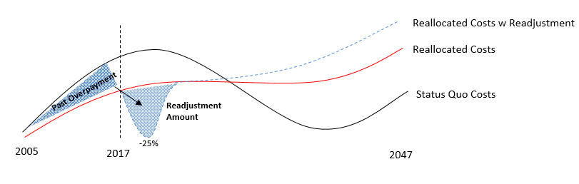

- The financing costs (interest and management fees) associated with the FHP are also included in the FAAs. OPG staff estimated the financing costs (5% interest + fees) and provided them to the Ministry of Energy. Those amounts have been included in the FAAs in the Minister’s letter.

FAA and Borrowing Capacity
- It is important to note the FAAs in the Minister’s letter include various components such as interest and management fees that do not allow for a direct comparison to debt capacity.
- OPG staff have worked with the Ministry of Energy on a financial model which takes the Fair Allocation Amounts and Readjustment Amounts and uses them to calculate debt capacity.

Implications for the FHP/Trust
- The Trust can only purchase regulatory assets if financing obligations related to the purchase align with the Fair Allocation Amounts.
- When the IESO offers a regulatory asset for sale to the Trust, as Financial Services Manager, OPG must asses whether the interest and principal repayment associated with the asset will align with the FAAs.
- OPG will use the model it developed with the Ministry to look at the total amount of positive FAAs that remain to be collected from customers to determine whether the asset can be purchased. The Trust can continue to purchase regulatory assets until total debt equals the total amount of remaining positive FAAs.
Reconciliation of FAA + Readjustment with FHP Debt Balance & Interest

