FAO ANALYSIS OF FAIR HYDRO PLAN
Summary of FAO Analysis
 | Cost to Province | Ratepayer Savings | Cost to Ratepayers
HST Rebate & Social Programs | ($45 billion) | $45 billion
Deferred Electricity Costs |  | $18.4 billion
Repayment of Deferred Electricity Costs |  |  | ($18.4 billion)
Interest on Deferred Electricity Costs |  |  | ($21 billion)
Total | ($45 billion) | $63.4 billion | ($39.4 billion)
Total FAO Net FHP Cost | ($21 billion)

Comments on the FAO Analysis
Interest Rate and Overall GA Refinancing Analysis
The FAO assumes a weighted average interest rate of 5% which is aligned with the Ministry of Energy and OPG’s assumption. As a result, the FAO’s financial analysis of the cost of the GA refinancing appears to be generally accurate.
GA Refinancing Structure
The main body of the FAO report assumes the Province will finance 45% of debt and the Trust the other remaining 55%. This is likely an overly simplification of the actual structure which will see the Trust financed using 51% debt from capital markets, 44% debt from OPG via an equity injection from the Province and 5% debt from OPG via corporate debt from capital markets. The appendix of the FAO report contains the following illustration which is a generally accurate portrayal of the financing structure:
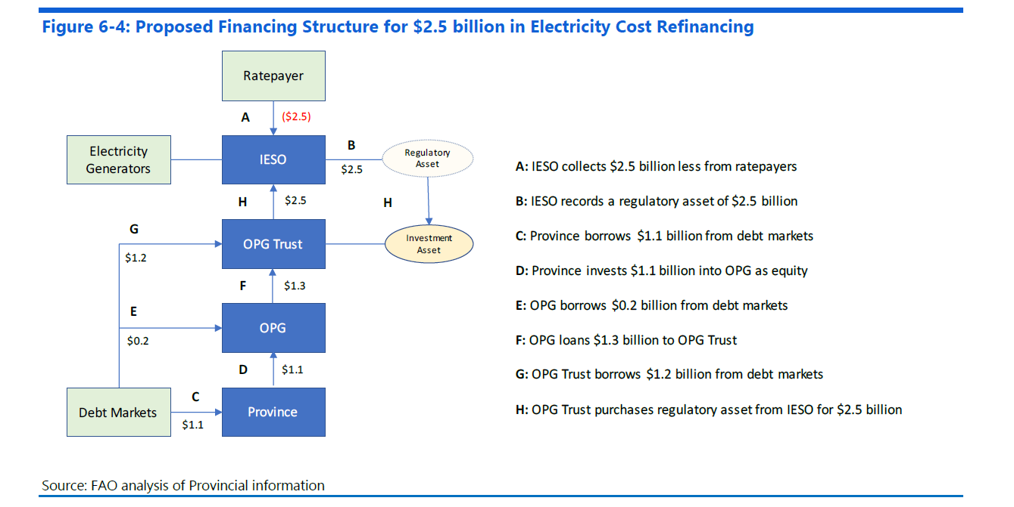
Overall Program Cost and Time Value of Money
The FAO does not consider the time-value of money when evaluating the net cost of the program. The FAO calculates the net cost of the FHP as the interest cost of the GA refinancing. However, this interest cost is used to pay for near-term savings for ratepayers with repayment occurring over the long-term.
If ratepayers’ discount rate is higher than the 5% interest rate assumed for GA refinancing debt, the FAO would have calculated a net benefit from the program. Many types of consumer debt have rates that are much higher than 5% such as credit card debt and payday loans. Other consumer debt may be lower such has mortgages for well qualified borrowers. The social discount rate is generally assumed to be in the range of 5% which would suggest the FHP has no net cost.
Savings if Province Financed 100% of the GA Refinancing
The FAO suggests that $4 billion could be saved if the GA refinancing were financed using 100% debt from the province at a 4.5% rate rather than the weighted average 5% rate when the Trust accesses capital markets. It is difficult to analyze this number without having access to the FAO’s financial model, but OPG analysis indicates the savings are more likely to be in the range of $3 billion.

